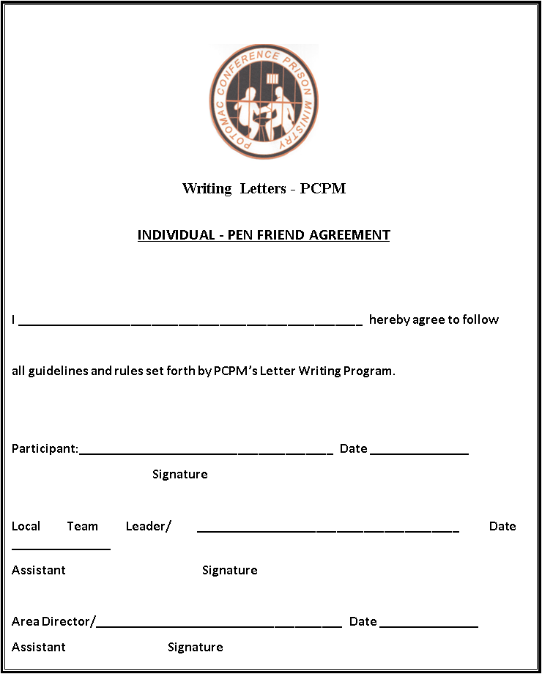

POTOMAC CONFERENCE PRISON MINISTRY FAMILY MINISTRY REQUEST FORM
I would like for someone who does not conduct programs or Bible Study classes at this institution to visit my family members (listed below), to determine their need for food, clothing, financial or Spiritual assistance: (I will inform them that I have made this request)
SPOUSE (WIFE /HUSBAND)
NAME (Please Print) ____________________________________
Address: __________________________________ City: ____________State: ______ Zip Code: ______ Telephone Number ( )____________
MINOR CHILDREN (UNDER 18)
Name of child: ____________________________ Age: __________
Address: ________________________________________ City:___________
Date of Birth: __/__/____ Sex_____ Telephone: (___) _____________
Caretaker’s Name: ______________________________Relationship to Child___________________________
Relationship to Inmate________________________Name of child: ___________________________ Age____
Address: __________________________________________City: ______________
Date of Birth: __/___/____ Sex____ Tel: (___) ______________Caretaker’s name: ______________________
Relationship to child___________________Relationship to inmate_______________________________
List additional children on back in same format
Inmate’s Signature _____________________________________Date: __________
Print Name____ _________________________ ______________Inmate #________________________
Facility: ____________________________________

Organizational Chart
Potomac Conference Executive committee

Potomac Conference
President Charles Tapp
Potomac Conference
VP Jose Vazquez
Prison Ministry



Senior Coordinator
Hank Branch
MEMBERSHIP SECRETARY

VIDEO CONFERENCING
DIRECTOR

English Coordinator
James Johnson
Hispanic Coordinator
Moises Escalera
BIBLE Study
CORRESPONDENCE

Letter Writing DIRECTOR

RE-ENTRY DIRECTOR

Treasure

Secretary

Assistant Treasure
Assistant English Coordinator

Assistant Hispanic Coordinator

FAMILY MINISTRY DIRECTOR
Assistant
Letter Writing

Potomac Conference Churches
Prison Ministry volunteers

COMUNICATION /Network DIRECTOR

LITERATURE DISTRIBUTION DIRECTOR

